**Lab Plan – 10 Machine Learning with Python**

In this step-by-step lab you will:

1. Download and install Python SciPy and get the most useful package for machine learning in Python.
2. Load a dataset and understand it’s structure using statistical summaries and data visualization.
3. Create 6 machine learning models, pick the best and build confidence that the accuracy is reliable.

If you are a machine learning beginner and looking to finally get started using Python, this tutorial was designed for you.

When you are applying machine learning to your own datasets, you are working on a project.

A machine learning project may not be linear, but it has a number of well known steps:

1. Define Problem.
2. Prepare Data.
3. Evaluate Algorithms.
4. Improve Results.
5. Present Results.

The best way to really come to terms with a new platform or tool is to work through a machine learning project end-to-end and cover the key steps. Namely, from loading data, summarizing data, evaluating algorithms and making some predictions.

If you can do that, you have a template that you can use on dataset after dataset. You can fill in the gaps such as further data preparation and improving result tasks later, once you have more confidence.

**Hello World of Machine Learning**

The best small project to start with on a new tool is the classification of iris flowers (e.g. [the iris dataset](https://archive.ics.uci.edu/ml/datasets/Iris)).

This is a good project because it is so well understood.

* Attributes are numeric so you have to figure out how to load and handle data.
* It is a classification problem, allowing you to practice with perhaps an easier type of supervised learning algorithm.
* It is a multi-class classification problem (multi-nominal) that may require some specialized handling.
* It only has 4 attributes and 150 rows, meaning it is small and easily fits into memory (and a screen or A4 page).
* All of the numeric attributes are in the same units and the same scale, not requiring any special scaling or transforms to get started.

Let’s get started with your hello world machine learning project in Python.

**Machine Learning in Python: Step-By-Step**

In this section, we are going to work through a small machine learning project end-to-end.

Here is an overview of what we are going to cover:

1. Installing the Python and SciPy platform.
2. Loading the dataset.
3. Summarizing the dataset.
4. Visualizing the dataset.
5. Evaluating some algorithms.
6. Making some predictions.

**Downloading, Installing and Starting Python SciPy**

Get the Python and SciPy platform installed on your system if it is not already.

I do not want to cover this in great detail, because others already have. This is already pretty straightforward, especially if you are a developer. If you do need help, ask a question in the comments.

**Install SciPy Libraries**

This tutorial assumes Python version 2.7 or 3.6+.

There are 5 key libraries that you will need to install. Below is a list of the Python SciPy libraries required for this tutorial:

* scipy
* numpy
* matplotlib
* pandas
* sklearn

There are many ways to install these libraries. My best advice is to pick one method then be consistent in installing each library.

The [scipy installation page](https://www.scipy.org/install.html) provides excellent instructions for installing the above libraries on multiple different platforms, such as Linux, mac OS X and Windows. If you have any doubts or questions, refer to this guide, it has been followed by thousands of people.

* On Mac OS X, you can use macports to install Python 3.6 and these libraries. For more information on macports, [see the homepage](https://www.macports.org/install.php).
* On Linux you can use your package manager, such as yum on Fedora to install RPMs.

If you are on Windows or you are not confident, I would recommend installing the free version of [Anaconda](https://www.continuum.io/downloads) that includes everything you need.

Type or copy and paste the following script:

# Check the versions of libraries

# Python version

import sys

print('Python: {}'.format(sys.version))

# scipy

import scipy

print('scipy: {}'.format(scipy.__version__))

# numpy

import numpy

print('numpy: {}'.format(numpy.__version__))

# matplotlib

import matplotlib

print('matplotlib: {}'.format(matplotlib.__version__))

# pandas

import pandas

print('pandas: {}'.format(pandas.__version__))

# scikit-learn

import sklearn

print('sklearn: {}'.format(sklearn.__version__))

Here is the output I get on my OS X workstation:

Python: 3.6.11 (default, Jun 29, 2020, 13:22:26)

[GCC 4.2.1 Compatible Apple LLVM 9.1.0 (clang-902.0.39.2)]

scipy: 1.5.2

numpy: 1.19.1

matplotlib: 3.3.0

pandas: 1.1.0

sklearn: 0.23.2

**Load The Data**

We are going to use the iris flowers dataset. This dataset is famous because it is used as the “hello world” dataset in machine learning and statistics by pretty much everyone.

The dataset contains 150 observations of iris flowers. There are four columns of measurements of the flowers in centimeters. The fifth column is the species of the flower observed. All observed flowers belong to one of three species.

In this step we are going to load the iris data from CSV file URL.

**Import libraries.**

# Load libraries

from pandas import read_csv

from pandas.plotting import scatter_matrix

from matplotlib import pyplot

from sklearn.model_selection import train_test_split

from sklearn.model_selection import cross_val_score

from sklearn.model_selection import StratifiedKFold

from sklearn.metrics import classification_report

from sklearn.metrics import confusion_matrix

from sklearn.metrics import accuracy_score

from sklearn.linear_model import LogisticRegression

from sklearn.tree import DecisionTreeClassifier

from sklearn.neighbors import KNeighborsClassifier

from sklearn.discriminant_analysis import LinearDiscriminantAnalysis

from sklearn.naive_bayes import GaussianNB

from sklearn.svm import SVC

...

Everything should load without error. If you have an error, stop. You need a working SciPy environment before continuing. See the advice above about setting up your environment.

**Load Dataset**

We can load the data directly from the UCI Machine Learning repository.

We are using pandas to load the data. We will also use pandas next to explore the data both with descriptive statistics and data visualization.

Note that we are specifying the names of each column when loading the data. This will help later when we explore the data.

Everything should load without error. If you have an error, stop. You need a working SciPy environment before continuing. See the advice above about setting up your environment.

**Load Dataset**

We can load the data directly from the UCI Machine Learning repository.

We are using pandas to load the data. We will also use pandas next to explore the data both with descriptive statistics and data visualization.

Note that we are specifying the names of each column when loading the data. This will help later when we explore the data.

# Load dataset

url = "https://raw.githubusercontent.com/jbrownlee/Datasets/master/iris.csv"

names = ['sepal-length', 'sepal-width', 'petal-length', 'petal-width', 'class']

dataset = read_csv(url, names=names)

The dataset should load without incident.

If you do have network problems, you can download the [iris.csv](https://raw.githubusercontent.com/jbrownlee/Datasets/master/iris.csv) file into your working directory and load it using the same method, changing URL to the local file name.

## **Summarize the Dataset**

Now it is time to take a look at the data.

In this step we are going to take a look at the data a few different ways:

1. Dimensions of the dataset.
2. Peek at the data itself.
3. Statistical summary of all attributes.
4. Breakdown of the data by the class variable.

Don’t worry, each look at the data is one command. These are useful commands that you can use again and again on future projects.

### Dimensions of Dataset

We can get a quick idea of how many instances (rows) and how many attributes (columns) the data contains with the shape property.

# shape

print(dataset.shape)

### Peek at the Data

# head

print(dataset.head(20))

You should see the first 20 rows of the data:

|  |  |
| --- | --- |
| 1  2  3  4  5  6  7  8  9  10  11  12  13  14  15  16  17  18  19  20  21 | sepal-length  sepal-width  petal-length  petal-width        class  0            5.1          3.5           1.4          0.2  Iris-setosa  1            4.9          3.0           1.4          0.2  Iris-setosa  2            4.7          3.2           1.3          0.2  Iris-setosa  3            4.6          3.1           1.5          0.2  Iris-setosa  4            5.0          3.6           1.4          0.2  Iris-setosa  5            5.4          3.9           1.7          0.4  Iris-setosa  6            4.6          3.4           1.4          0.3  Iris-setosa  7            5.0          3.4           1.5          0.2  Iris-setosa  8            4.4          2.9           1.4          0.2  Iris-setosa  9            4.9          3.1           1.5          0.1  Iris-setosa  10           5.4          3.7           1.5          0.2  Iris-setosa  11           4.8          3.4           1.6          0.2  Iris-setosa  12           4.8          3.0           1.4          0.1  Iris-setosa  13           4.3          3.0           1.1          0.1  Iris-setosa  14           5.8          4.0           1.2          0.2  Iris-setosa  15           5.7          4.4           1.5          0.4  Iris-setosa  16           5.4          3.9           1.3          0.4  Iris-setosa  17           5.1          3.5           1.4          0.3  Iris-setosa  18           5.7          3.8           1.7          0.3  Iris-setosa  19           5.1          3.8           1.5          0.3  Iris-setosa |

### Statistical Summary

Now we can take a look at a summary of each attribute.

|  |
| --- |
| This includes the count, mean, the min and max values as well as some percentiles....  # descriptions  print(dataset.describe()) |

We can see that all of the numerical values have the same scale (centimeters) and similar ranges between 0 and 8 centimeters.

|  |  |
| --- | --- |
| 1  2  3  4  5  6  7  8  9 | sepal-length  sepal-width  petal-length  petal-width  count    150.000000   150.000000    150.000000   150.000000  mean       5.843333     3.054000      3.758667     1.198667  std        0.828066     0.433594      1.764420     0.763161  min        4.300000     2.000000      1.000000     0.100000  25%        5.100000     2.800000      1.600000     0.300000  50%        5.800000     3.000000      4.350000     1.300000  75%        6.400000     3.300000      5.100000     1.800000  max        7.900000     4.400000      6.900000     2.500000 |

### Class Distribution

Let’s now take a look at the number of instances (rows) that belong to each class. We can view this as an absolute count.

|  |
| --- |
| # class distribution  print(dataset.groupby('class').size()) |

We can see that each class has the same number of instances (50 or 33% of the dataset).

|  |
| --- |
| Class  Iris-setosa        50  Iris-versicolor    50  Iris-virginica     50 |

### Complete Example

For reference, we can tie all of the previous elements together into a single script.

The complete example is listed below.

|  |
| --- |
| # summarize the data  from pandas import read_csv  # Load dataset  url = "https://raw.githubusercontent.com/jbrownlee/Datasets/master/iris.csv"  names = ['sepal-length', 'sepal-width', 'petal-length', 'petal-width', 'class']  dataset = read_csv(url, names=names)  # shape  print(dataset.shape)  # head  print(dataset.head(20))  # descriptions  print(dataset.describe())  # class distribution  print(dataset.groupby('class').size()) |

## **Data Visualization**

We now have a basic idea about the data. We need to extend that with some visualizations.

We are going to look at two types of plots:

1. Univariate plots to better understand each attribute.
2. Multivariate plots to better understand the relationships between attributes.

### Univariate Plots

We start with some univariate plots, that is, plots of each individual variable.

Given that the input variables are numeric, we can create box and whisker plots of each.

|  |
| --- |
| # box and whisker plots  dataset.plot(kind='box', subplots=True, layout=(2,2), sharex=False, sharey=False)  pyplot.show() |

This gives us a much clearer idea of the distribution of the input attributes:

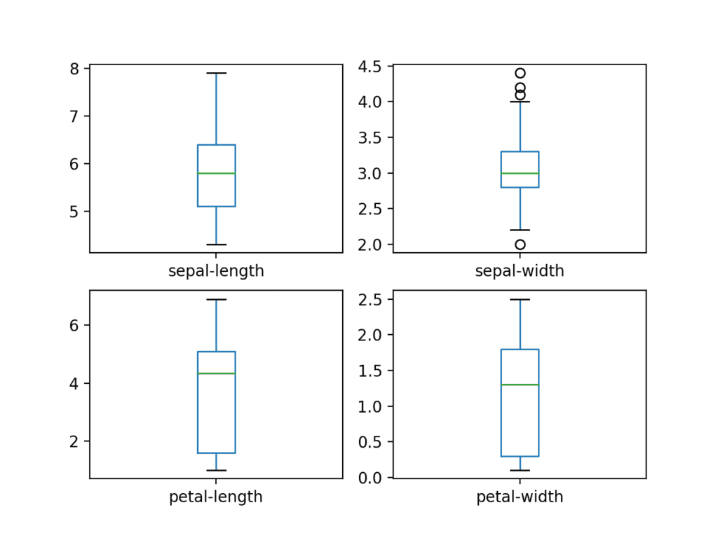

Box and Whisker Plots for Each Input Variable for the Iris Flowers Dataset

We can also create a histogram of each input variable to get an idea of the distribution.

|  |
| --- |
| ...  # histograms  dataset.hist()  pyplot.show() |

It looks like perhaps two of the input variables have a Gaussian distribution. This is useful to note as we can use algorithms that can exploit this assumption.

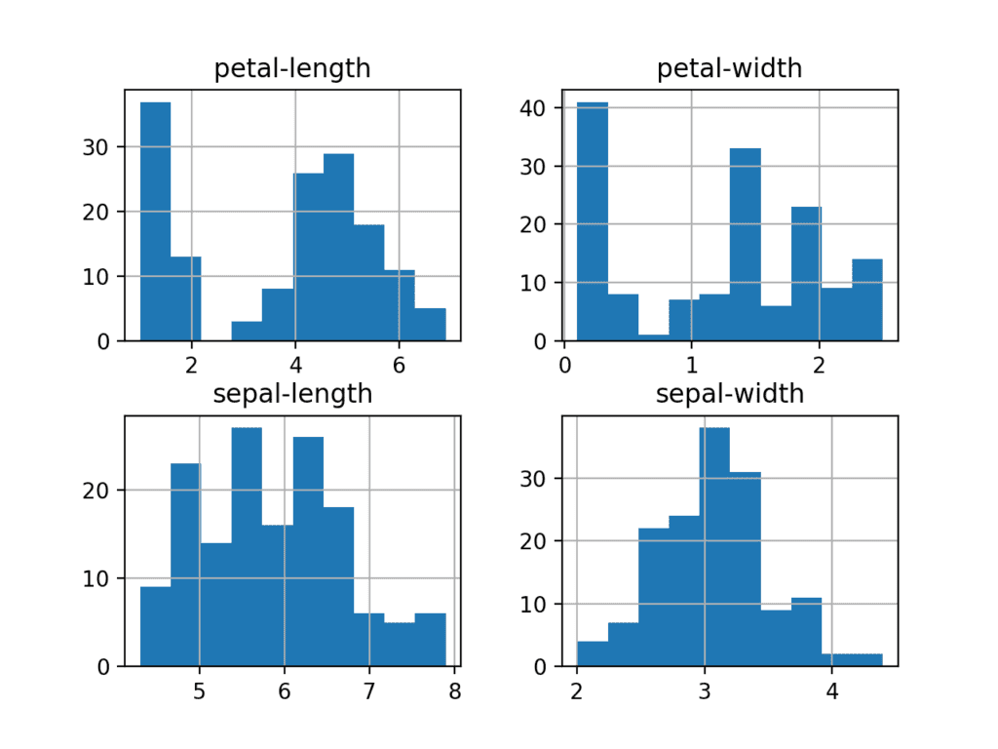

Histogram Plots for Each Input Variable for the Iris Flowers Dataset

### Multivariate Plots

Now we can look at the interactions between the variables.

First, let’s look at scatterplots of all pairs of attributes. This can be helpful to spot structured relationships between input variables.

|  |
| --- |
| ...  # scatter plot matrix  scatter_matrix(dataset)  pyplot.show() |

Note the diagonal grouping of some pairs of attributes. This suggests a high correlation and a predictable relationship.

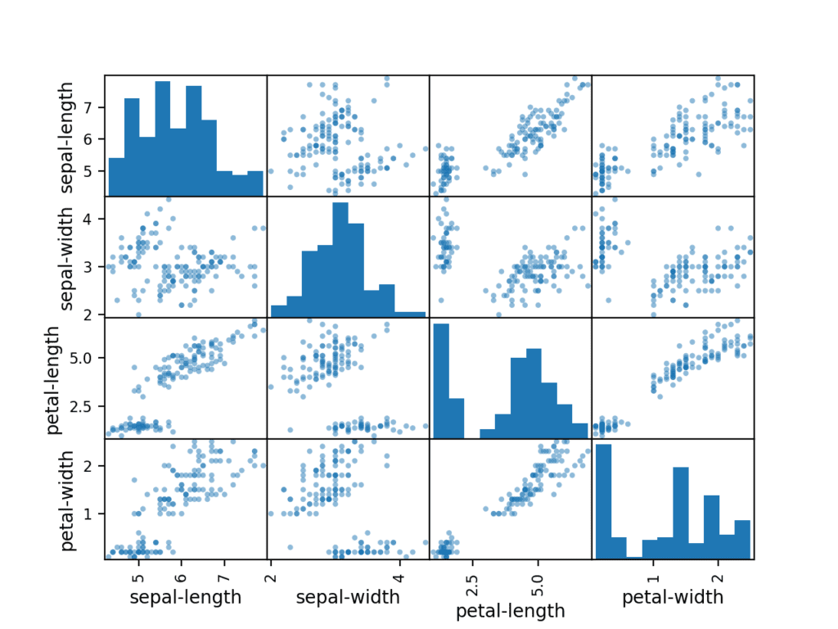

Scatter Matrix Plot for Each Input Variable for the Iris Flowers Dataset

### Complete Example

For reference, we can tie all of the previous elements together into a single script.

The complete example is listed below.

|  |
| --- |
| # visualize the data  from pandas import read_csv  from pandas.plotting import scatter_matrix  from matplotlib import pyplot  # Load dataset  url = "https://raw.githubusercontent.com/jbrownlee/Datasets/master/iris.csv"  names = ['sepal-length', 'sepal-width', 'petal-length', 'petal-width', 'class']  dataset = read_csv(url, names=names)  # box and whisker plots  dataset.plot(kind='box', subplots=True, layout=(2,2), sharex=False, sharey=False)  pyplot.show()  # histograms  dataset.hist()  pyplot.show()  # scatter plot matrix  scatter_matrix(dataset)  pyplot.show() |

## 5. Evaluate Some Algorithms

Now it is time to create some models of the data and estimate their accuracy on unseen data.

Here is what we are going to cover in this step:

1. Separate out a validation dataset.
2. Set-up the test harness to use 10-fold cross validation.
3. Build multiple different models to predict species from flower measurements
4. Select the best model.

### Create a Validation Dataset

We need to know that the model we created is good.

Later, we will use statistical methods to estimate the accuracy of the models that we create on unseen data. We also want a more concrete estimate of the accuracy of the best model on unseen data by evaluating it on actual unseen data.

That is, we are going to hold back some data that the algorithms will not get to see and we will use this data to get a second and independent idea of how accurate the best model might actually be.

We will split the loaded dataset into two, 80% of which we will use to train, evaluate and select among our models, and 20% that we will hold back as a validation dataset.

|  |
| --- |
| ...  # Split-out validation dataset  array = dataset.values  X = array[:,0:4]  y = array[:,4]  X_train, X_validation, Y_train, Y_validation = train_test_split(X, y, test_size=0.20, random_state=1) |

You now have training data in the X_train and Y_train for preparing models and a X_validation and Y_validation sets that we can use later.

Notice that we used a python slice to select the columns in the NumPy array. If this is new to you, you might want to check-out this post:

* [How to Index, Slice and Reshape NumPy Arrays for Machine Learning in Python](https://machinelearningmastery.com/index-slice-reshape-numpy-arrays-machine-learning-python/)

### Test Harness

We will use stratified 10-fold cross validation to estimate model accuracy.

This will split our dataset into 10 parts, train on 9 and test on 1 and repeat for all combinations of train-test splits.

Stratified means that each fold or split of the dataset will aim to have the same distribution of example by class as exist in the whole training dataset.

For more on the k-fold cross-validation technique, see the tutorial:

* [A Gentle Introduction to k-fold Cross-Validation](https://machinelearningmastery.com/k-fold-cross-validation/)

We set the random seed via the random_state argument to a fixed number to ensure that each algorithm is evaluated on the same splits of the training dataset.

The specific random seed does not matter, learn more about pseudorandom number generators here:

* [Introduction to Random Number Generators for Machine Learning in Python](https://machinelearningmastery.com/introduction-to-random-number-generators-for-machine-learning/)

We are using the metric of ‘accuracy‘ to evaluate models.

This is a ratio of the number of correctly predicted instances divided by the total number of instances in the dataset multiplied by 100 to give a percentage (e.g. 95% accurate). We will be using the scoring variable when we run build and evaluate each model next.

### Build Models

We don’t know which algorithms would be good on this problem or what configurations to use.

We get an idea from the plots that some of the classes are partially linearly separable in some dimensions, so we are expecting generally good results.

Let’s test 6 different algorithms:

* Logistic Regression (LR)
* Linear Discriminant Analysis (LDA)
* K-Nearest Neighbors (KNN).
* Classification and Regression Trees (CART).
* Gaussian Naive Bayes (NB).
* Support Vector Machines (SVM).

This is a good mixture of simple linear (LR and LDA), nonlinear (KNN, CART, NB and SVM) algorithms.

Let’s build and evaluate our models:

|  |
| --- |
| ...  # Spot Check Algorithms  models = []  models.append(('LR', LogisticRegression(solver='liblinear', multi_class='ovr')))  models.append(('LDA', LinearDiscriminantAnalysis()))  models.append(('KNN', KNeighborsClassifier()))  models.append(('CART', DecisionTreeClassifier()))  models.append(('NB', GaussianNB()))  models.append(('SVM', SVC(gamma='auto')))  # evaluate each model in turn  results = []  names = []  for name, model in models:  kfold = StratifiedKFold(n_splits=10, random_state=1, shuffle=True)  cv_results = cross_val_score(model, X_train, Y_train, cv=kfold, scoring='accuracy')  results.append(cv_results)  names.append(name)  print('%s: %f (%f)' % (name, cv_results.mean(), cv_results.std())) |

### Select Best Model

We now have 6 models and accuracy estimations for each. We need to compare the models to each other and select the most accurate.

Running the example above, we get the following raw results:

|  |
| --- |
| LR: 0.960897 (0.052113)  LDA: 0.973974 (0.040110)  KNN: 0.957191 (0.043263)  CART: 0.957191 (0.043263)  NB: 0.948858 (0.056322)  SVM: 0.983974 (0.032083) |

**Note**: Your [results may vary](https://machinelearningmastery.com/different-results-each-time-in-machine-learning/) given the stochastic nature of the algorithm or evaluation procedure, or differences in numerical precision. Consider running the example a few times and compare the average outcome.

**What scores did you get?**  
Post your results in the comments below.

In this case, we can see that it looks like Support Vector Machines (SVM) has the largest estimated accuracy score at about 0.98 or 98%.

We can also create a plot of the model evaluation results and compare the spread and the mean accuracy of each model. There is a population of accuracy measures for each algorithm because each algorithm was evaluated 10 times (via 10 fold-cross validation).

A useful way to compare the samples of results for each algorithm is to create a box and whisker plot for each distribution and compare the distributions.

|  |
| --- |
| ...  # Compare Algorithms  pyplot.boxplot(results, labels=names)  pyplot.title('Algorithm Comparison')  pyplot.show() |

We can see that the box and whisker plots are squashed at the top of the range, with many evaluations achieving 100% accuracy, and some pushing down into the high 80% accuracies.

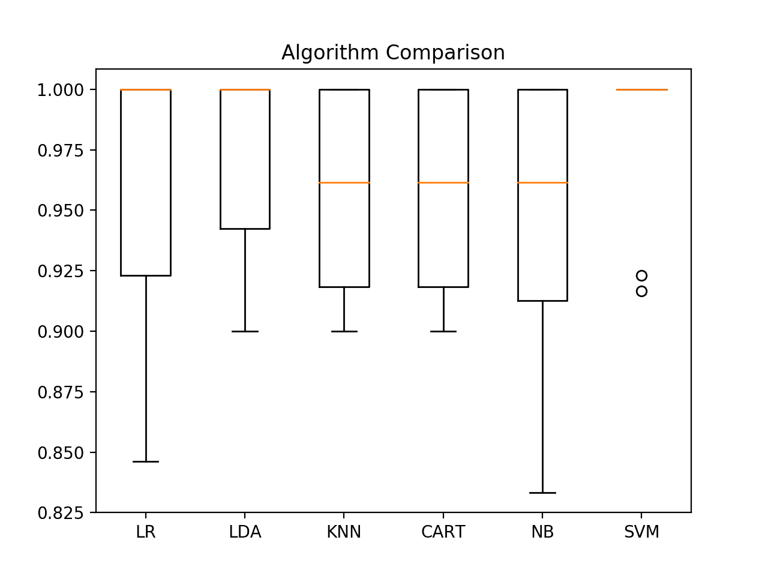

Box and Whisker Plot Comparing Machine Learning Algorithms on the Iris Flowers Dataset

### 5.5 Complete Example

For reference, we can tie all of the previous elements together into a single script.

The complete example is listed below.

|  |
| --- |
| # compare algorithms  from pandas import read_csv  from matplotlib import pyplot  from sklearn.model_selection import train_test_split  from sklearn.model_selection import cross_val_score  from sklearn.model_selection import StratifiedKFold  from sklearn.linear_model import LogisticRegression  from sklearn.tree import DecisionTreeClassifier  from sklearn.neighbors import KNeighborsClassifier  from sklearn.discriminant_analysis import LinearDiscriminantAnalysis  from sklearn.naive_bayes import GaussianNB  from sklearn.svm import SVC  # Load dataset  url = "https://raw.githubusercontent.com/jbrownlee/Datasets/master/iris.csv"  names = ['sepal-length', 'sepal-width', 'petal-length', 'petal-width', 'class']  dataset = read_csv(url, names=names)  # Split-out validation dataset  array = dataset.values  X = array[:,0:4]  y = array[:,4]  X_train, X_validation, Y_train, Y_validation = train_test_split(X, y, test_size=0.20, random_state=1, shuffle=True)  # Spot Check Algorithms  models = []  models.append(('LR', LogisticRegression(solver='liblinear', multi_class='ovr')))  models.append(('LDA', LinearDiscriminantAnalysis()))  models.append(('KNN', KNeighborsClassifier()))  models.append(('CART', DecisionTreeClassifier()))  models.append(('NB', GaussianNB()))  models.append(('SVM', SVC(gamma='auto')))  # evaluate each model in turn  results = []  names = []  for name, model in models:  kfold = StratifiedKFold(n_splits=10, random_state=1, shuffle=True)  cv_results = cross_val_score(model, X_train, Y_train, cv=kfold, scoring='accuracy')  results.append(cv_results)  names.append(name)  print('%s: %f (%f)' % (name, cv_results.mean(), cv_results.std()))  # Compare Algorithms  pyplot.boxplot(results, labels=names)  pyplot.title('Algorithm Comparison')  pyplot.show() |

## **Make Predictions**

We must choose an algorithm to use to make predictions.

The results in the previous section suggest that the SVM was perhaps the most accurate model. We will use this model as our final model.

Now we want to get an idea of the accuracy of the model on our validation set.

This will give us an independent final check on the accuracy of the best model. It is valuable to keep a validation set just in case you made a slip during training, such as overfitting to the training set or a data leak. Both of these issues will result in an overly optimistic result.

### Make Predictions

We can fit the model on the entire training dataset and make predictions on the validation dataset.

|  |
| --- |
| # Make predictions on validation dataset  model = SVC(gamma='auto')  model.fit(X_train, Y_train)  predictions = model.predict(X_validation) |

You might also like to make predictions for single rows of data. For examples on how to do that, see the tutorial:

* [How to Make Predictions with scikit-learn](https://machinelearningmastery.com/make-predictions-scikit-learn/)

You might also like to save the model to file and load it later to make predictions on new data. For examples on how to do this, see the tutorial:

* [Save and Load Machine Learning Models in Python with scikit-learn](https://machinelearningmastery.com/save-load-machine-learning-models-python-scikit-learn/)

**Evaluate Predictions**

We can evaluate the predictions by comparing them to the expected results in the validation set, then calculate classification accuracy, as well as a [confusion matrix](https://machinelearningmastery.com/ufaqs/what-is-a-confusion-matrix/) and a classification report.

|  |
| --- |
| ....  # Evaluate predictions  print(accuracy_score(Y_validation, predictions))  print(confusion_matrix(Y_validation, predictions))  print(classification_report(Y_validation, predictions)) |

We can see that the accuracy is 0.966 or about 96% on the hold out dataset.

The confusion matrix provides an indication of the errors made.

Finally, the classification report provides a breakdown of each class by precision, recall, f1-score and support showing excellent results (granted the validation dataset was small).

|  |
| --- |
| 0.9666666666666667  [[11  0  0]  [ 0 12  1]  [ 0  0  6]]                   precision    recall  f1-score   support        Iris-setosa       1.00      1.00      1.00        11  Iris-versicolor       1.00      0.92      0.96        13  Iris-virginica       0.86      1.00      0.92         6           accuracy                           0.97        30        macro avg       0.95      0.97      0.96        30     weighted avg       0.97      0.97      0.97        30 |

### Complete Example

For reference, we can tie all of the previous elements together into a single script.

The complete example is listed below.

|  |
| --- |
| # make predictions  from pandas import read_csv  from sklearn.model_selection import train_test_split  from sklearn.metrics import classification_report  from sklearn.metrics import confusion_matrix  from sklearn.metrics import accuracy_score  from sklearn.svm import SVC  # Load dataset  url = "https://raw.githubusercontent.com/jbrownlee/Datasets/master/iris.csv"  names = ['sepal-length', 'sepal-width', 'petal-length', 'petal-width', 'class']  dataset = read_csv(url, names=names)  # Split-out validation dataset  array = dataset.values  X = array[:,0:4]  y = array[:,4]  X_train, X_validation, Y_train, Y_validation = train_test_split(X, y, test_size=0.20, random_state=1)  # Make predictions on validation dataset  model = SVC(gamma='auto')  model.fit(X_train, Y_train)  predictions = model.predict(X_validation)  # Evaluate predictions  print(accuracy_score(Y_validation, predictions))  print(confusion_matrix(Y_validation, predictions))  print(classification_report(Y_validation, predictions)) |